At Ethel, WA
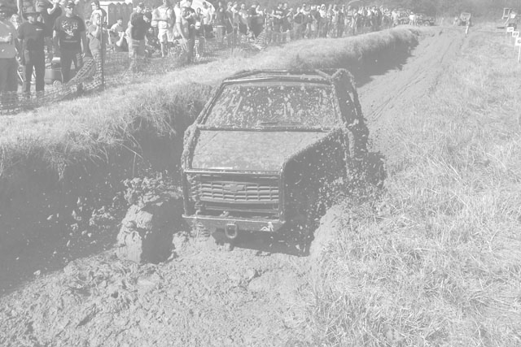
Good, “Clean” Family Fun!

Spectator Admission: $10 (↓10 free)

Registration: $40
Participant gate opens: 7:00 am
Spectator gate opens: 8:00 am
Drivers meeting: 8:30 am

Boggin’ begins! 9:00 am

Award presentation: 45 minutes after last run

On site: Food, Beverages, Restrooms
For more information, Contact: Aaron at jeepguy91@cascade4x4s.com or Mudbog@cascade4x4s.com

Event Information
- Event limited to 100 participants.
- Registration at the gate Friday and Saturday.
- Registration closes day of event at 10:00 AM.
- Spectator gate opens at 8:00 AM.
- Mandatory drivers meeting at
8:30 AM.
- Boggin’ begins at 9:00 AM.
- Winners will be determined by best time or longest distance traveled.
- Trophies Awarded—Top 3 finishers per class, 45 minutes after last run.
- Look for event photos in Tri-Power and on the web at Cascade4x4s.com

Participant Rules
- All drivers must wear a seatbelt and helmet.
- Recommend vehicles have front and rear tow hooks.
- Vehicles must have a fire extinguisher. (Rentals Available)
- Passenger allowed, but must
wear helmet and seat belt.
- The possibility of vehicle damage and broken parts exists. Enter at own risk.
- No loose items. Batteries and Fire Extinguishers must be securely attached.
- All Participant vehicles will be asked to pressure washed before leaving event.
General Rules
- Children must be accompanied
by a parent at all times.
- Please put garbage in trash receptacles.
- Pets must be on leash at all times.
- NO ALCOHOL OR WEAPONS ALLOWED.
- Gate fees are non-refundable.
- All workers are volunteers, please be respectful of the job they are trying to do.
7) Please respect the property, any vehicle or driver found horse playing in field will be asked to leave.
8) HAVE FUN!

DIRECTIONS  Happ’s Property, Ethel, WA  Just 75 miles south of Tacoma!  From I-5 N or S, take exit #68 (Hwy 12 East) towards Morton/Yakima.  Follow Hwy 12E about 7.5 miles.  At the intersection, turn left onto Leonard Road.  Go about 1 mile and turn left on Larmon Rd.  Go about 1 mile and turn left into the driveway. |  | 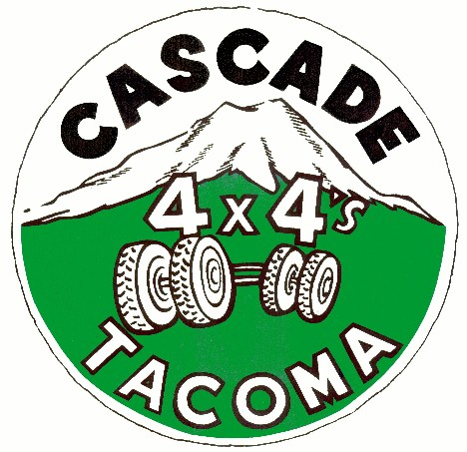

Registration at Gate
Driver Name |  |  | _____________________________
Address |  | _________________________________ |  |  |  |  |  | City/State/Zip_____________________
Phone | __________________________________ |  |  |  |  |  |  | E-mail __________________________
Class: Tire Size |  |  |  | Up to 35” ____ |  |  | 36-39” ____ | 40”&↑ ____ |  |  | Unlimited ____
Make Checks  Payable to:  Cascade 4x4’s of Tacoma |  |  |  |  | Registration Fee: $ _________  (One driver & vehicle)  Extra Class Fee: $ _________  *Camping Fee: $ _________  Gate Fee: $ _________  TOTAL: $ _________ |  |  |  |  | ($40 includes gate and registration fee)  ($20 per extra class)  ($30 per family- Gates locked at 11:00 pm)  ($10 per person, ↓ 10 free- For extra guests)
*For security purposes gate will close at 11:00 pm and will not open until 7:00 am. No EXCEPTIONS!!!!!

I understand there may be risk associated with an event of this nature. I will not hold the sponsors, Region II, the PNW4WDA and/or the landowners responsible for any and all damages. I have read and understand the Event Information and Rules as stated above.

Signature ____________________________________________ Date ____________________________

