Snow Jam
Meet & Greet 2010
Hosted by:
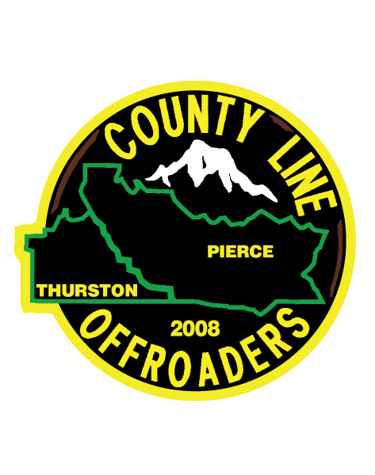
January 23, 2010-Saturday
8:00 a.m.-First rig out
Noon- Last rig out

Starting at Scott Turner Road and ending at the Elbe Hills camp ground.

Registration-$10/Includes one hand
$5 for extra hands
Prizes / Raffle
Chili Feed (with all the fixins’)
Cocoa
Bring your rig, family, sleds and get ready to have a good time!
Have any questions?
(360) 458-0644 or (253) 350-2584

